**FYP Final Report**

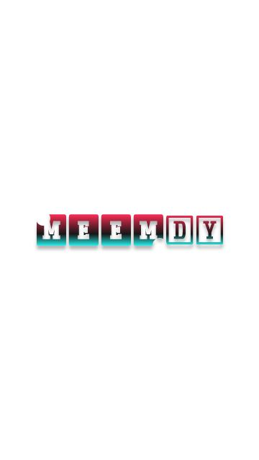

Final Year Project Report

by

**Imran Ali, Ghulam Hussain & Rajesh Kumar**

In Partial Fulfillment

Of the Requirements for the degree

Bachelor of Science (CS/SE)

Sukkur IBA University,

Sukkur, Sindh Pakistan

(2022)

**MEMDY**

by

**Imran Ali, Ghulam Hussain & Rajesh Kumar**

SUBMITTED TO THE DEPARTMENT OF COMPUTER SCIENCE IN PARTIAL FULFILLMENT OF THE REQUIREMENTS FOR THE DEGREE OF

**BACHELOR OF SCIENCE IN COMPUTER SCIENCE / SOFTWARE ENGINEERING**

At the

SUKKUR IBA University

**October 2022**

**© 2022 Imran Ali, Ghulam Hussain & Rajesh Kumar** All rights reserved.

The author hereby grants permission to Sukkur IBA to reproduce and distribute publicly paper and electronic copies of this thesis and grant others the right to do so.

Signature of Author(s)

**Imran Ali, Ghulam Hussain & Rajesh Kumar**

Certified by: Internal Examiner

External Examiner

Accepted by:

**DECLARATION**

“We hereby declare that this project report entitled **“MEMDY”** submitted to the “Computer Science”, is a record of an original work done by us under the guidance of Supervisor Mr. Khalid Hussain and that no part has been plagiarized without citations. Also, this project work is submitted in partial fulfillment of the requirements for the degree of Bachelor of Computer Science.”

|  |  |  |
| --- | --- | --- |
| **Team Members** | **Signature** | |
| Imran Ali | | _____________________ |
| Ghulam Hussain  Rajesh Kumar | |  |
| **Supervisor:** | | **Signature** |
| Mr. Khalid Hussain | | _____________________ |
| **Date:** ______________ | |  |
| **Place:** ______________ | |  |
|  | |  |
|  | |  |
|  | |  |

**DEDICATION**

*We are dedicating this work to our lovable parents who brought us into this world makes us capable and our teachers who always supported us and taught us how to fly and become successful. We are especially thankful to our FYP supervisor****, Mr. Khalid Hussain****, who supported us at every stage throughout the whole process of work and become our dedication.*

Table of Contents

Table of Figures 8

ABSTRACT 9

1. INTRODUCTION AND BACKGROUND 10

1.1 Project Scope……………………………………………………………………......10

1.2 System Constraints………………………………………………………………......10

2. PROBLEM IDENTIFICATION 11

2.1. TARGET CUSTOMERS 11

3. LITERATURE REVIEW 12

3.1.1. Language Barrier 12

4. METHODOLOGY 14

4.1. Overview 14

4.2. Development Approach 14

4.2.1. Micro Service Architecture 14

4.3. Tools and Technologies 14

4.3.1. Backend Technologies 14

4.3.2. Frontend Technologies 14

4.3.3. Database 14

4.3.4. Tools 14

5. DETAILED DESIGN AND ARCHITECTURE 15

1. System Architecture 15

2. Architecture Design Diagram 16

3. Entity Relationship Diagram (ERD) 17

4. Class Diagram 18

5. Sequence Diagrams 19

5.1. User Registration Sequence Diagram 19

5.2. User Login Sequence Diagram 20

6. Functional Requirements 22

6.1. Functional Hierarchy 22

6.2. Database Diagram 22

6.3. Use Cases 22

7. Non-functional Requirements 26

7.1. Performance Requirements 26

7.2. Safety Requirements 27

7.3. Security Requirements 27

7.4. User Documentation 27

8. IMPLEMENTATION AND TESTING 28

8.1. System Implementation 28

8.1.1. Web Application 28

8.1.2. React-Native Framework 28

8.2. Mobile App Development 29

8.3. React-Native 29

8.4. Database 29

8.5. Mongo DB 29

8.6. Backend Implementation Details 30

8.7. Working Endpoints for Front End Application 30

8.8. Front End Design Implementation Details 32

8.8.1. Web Application login 32

8.8.2. Web Application Registeration 32

8.8.3. Web Application Password Reset 33

8.8.4. Web Application Home Page 34

8.8.5. Web Application Dashboard 34

8.8.6. Mobile Application 34

8.8.6.1. Mobile Application login & Sign up 34

8.8.6.2. Mobile Application Profile Screen 34

8.8.6.3. Mobile Application Home Screen 34

9. CONCLUSION 42

10. Limitations and Future Work 42

11. REFERENCES 43

# ABSTRACT

Entertainment is necessary to keep the human mood fresh. For serenity, Memes play an important role that shares humans to humans, their ideas, value or patterns of behaviors through memes. Along with it, meme has role in such regard to helping people live joyfully (Xie el, at. 2011). Memer's community is being rapidly expanding in this age of social media. They've become our go-to source of fun in our daily routine. Memer’s exhibit their creativity through memes that delight people, but it's fair to argue that they spend their time being creative, but they still do not get any reward for doing this. They put their efforts and still are unable to make money for creating joyful memes. Therefore, we propose a tool and social web app to the meme creators for two reasons, firstly, memer’s may produce trending, entertaining, and informative memes and secondly, they can earn money from the app. But they need to be monetized themselves. They will be paid coins as a reward and which will be converted into cash and can be withdrawn later. Lastly, this web app will be developed using React JS for the front-end, Node JS for the backend, and Mongo DB for Database. This tool will be web-based, but it will also include functionality for generating and editing in a (social media) mobile app.

**Key Terms:** Memes, Entertainment, Social-media, React JS, Node JS, Mongo DB

# INTRODUCTION AND BACKGROUD

After uprising of Digital media, Entertainment becomes necessary to keep mood fresh. Everyone is looking for to keep its mood fresh. Keeping mood fresh is a challenging thing in this time because everyone is facing some type of problem (Xie el, at. 2011). One of medium of making mood positive is using social media. This he to make their humans their mood refresh through social media, social media has become important part of our lives where everyone used to spend most of its time and try to entertain itself.

To keep people entertain on social media Memer’s play a prominent role in such regard to helping people live joyfully. Memes are created by the memer’s and shared on social media platforms like Facebook, Instagram and whatsApp. Memer’s spend their time put their efforts to create good memes, they spread happiness on social media. Memer’s community is not famous as YouTube community. They are also not earning from social platform.

The purpose of this study is to create a platform with the name “MemDY” in which memer’s get all functions in a single platform such as editing tools, content related to memes and platform where memer’s can share their memes on the same time. Additionally, the community of memer’s get fame from this platform with earning as well. MemDY application will be consist on two modes web application and mobile application.

Web application consist on following features;

* Editing Tool
* Search and filters
* Library of memes
* Supporting media
* Social platform

Editing tool will be consist of typography, frames, filters and colors. In search and filters there will be different filters which will be applied on image like black and white, fresh, night, movie, food and travel once the user search the image then filters can be applied on image.

Meme library consists of trending memes of other memer’s and those meme image can be edited by the other Memer. Supporting media is also consist on images where different type of images is available and these images can be selected by the Memer. Once Meme is created then it can be publish on social platform, in social platform that meme will be added to memer’s profile and meme will be visible to the user on mobile application. In web application Memer can create meme and can share it on social platform. After publishing the image on social platform it will be visible to users on mobile application where user can like and share and comment on meme.

Application interface will be similar like Tiktok where user can scroll up and down to see different meme of different memer’s. Trending memes will be shown to the users first once the application is opened. Memer can earn through coin base system coins will be generated. The more like’s memer’s meme gets then more coins will be generated and through that coins Memer can earn money. Memer’s can also earn through promoting different brands by their memes.

Memer can get fame through follower the more follower Memer gets then more fame Memer gets. MemDY platform provides a proper platform to the memer’s where they can get fame and earn money, through MemDY memer’s can build their career.

* 1. **Project Scope**

“MEMDY” is a web-based application and mobile application. Currently there is no proper platform for memer’s where they can get fame. Memer’s creates memes and share them onto different platforms but they don’t get fame, although they create memes on different platforms and shares them. “MEMDY” will provide a proper social platform to memer’s where memer’s can edit and share memes. MemDy is consist on two modes. Web Application where memes can be created and then memes will be published that meme will be added to memer’s profile.

* 1. **System Constraints**

Internet connection is a constraint for both web-application and mobile application because both needs to fetch date from the database which is stored on server so internet should be available for performing function.

Database is centralized for both mobile and web application so it’s another constraint and it might be possible some delay may occur while fetching data.

Sometime memes are used to troll or make fun of someone it’s another constraint. Mobile application will not support those devices which has android version less than 4.2.

# PROBLEM IDENTIFICATION

Problem is identified when it’s been observed that memer’s putting their efforts to create memes and share them on social platform’s like Facebook, Instagram and whatsApp. People enjoy and keeps their moods refresh through those memes, there is no any proper tool is available for memer’s where they can create meme and share on a single platform. They used to share memes on different platforms.

Becoming as memer’s, looks hidden talent which doesn’t have platform for getting fame and earning like others platform such as YouTube, Facebook and Twitter.

**2.1. TARGET CUSTOMERS**

There are two types of target customers.

* **Memer’s:** The memer’s will create memes.
* **Users:** The audience who will use application to see the memes for entertaining purposes.
* **Clients:**

# LITERATURE REVIEW

In the light of literature, a number of websites and application are found in which the memes can be used for entertaining purpose (Xie el, at. 2011). Along with it, this culture has also trending on marketing purpose in the business field. One of the platform in literature is memes website ([www.memes.com](http://www.memes.com)) in which Memer is able to create memes and post on the same platform. Canva is also one of the platform that provides resources related to create memes only (www.canvas.coms). It is web-application that provides image editing features and video editing. Additionally, it has some other features that different from memes features such as resuming, letter, report and planning. In designing section, it is providing platform of making logo, flyers, posters, blog banner, business card and label making. Image editing is a features which is flexible to share the same edited image to the social platform by sharing option. This canvas two modes; Free & Paid; free has very specific option that affects audience to visit again and paid version is very costly that allows memer’s to use this paid version only for entertaining.

Above literature shows lots of gape in this field that helps research to state a problem. In memes.com website doesn’t have any earning system which attract developers to update its website accordingly. This application is exist as only website as the demand of users is android which means mobile application that is missing in this platform. In canva platform, there is no any attractive material that emphasis memer’s to invest their costs for creating such a meme which helps memer’s to get fame or any sponsorship. These platform needs to look at these gapes for making applications on the top.

* 1. **PROJECT GOAL**

The main goal of this MEMDY project is to provide an online platform for memer’s where they can create memes and share them on same platform instead of sharing onto other platforms. This project will also help memer’s to get fame, earn money and became popular on social media. This project will helps memer’s to set a career in the field of memes.

## **Language Barrier**

* Tool will be in English Language which will be easy to understand by all memer’s and users.
* Memes can be edited and shared in any language as per the wish of Memer.

# METHODOLOGY

## **Overview**

This section describes development methodology of our project will be applied by us throughout the whole project, while executing the system. It will also identifies the further development strategies, approaches and tools which will be used during the development.

## **4.2 Development Approach**

Easy Bazaar, an online marketplace has been developed by adapting the agile mindset. The website has been broken-down into sub-systems for the ease of development. Agile methodology enabled a way to fast-track the development of the system.

## **4.2.1 Micro service Architecture**

A micro services architecture is a type of application architecture where the application is developed as a collection of services. It provides the framework to develop, deploy, and maintain micro services architecture diagrams and services independently.

In order to implement this approach, Scrum was used to manage the project. Following activities were performed in the scrum

The main purpose of using this architecture it will be easy to manage the project because each service/module is implemented separately.

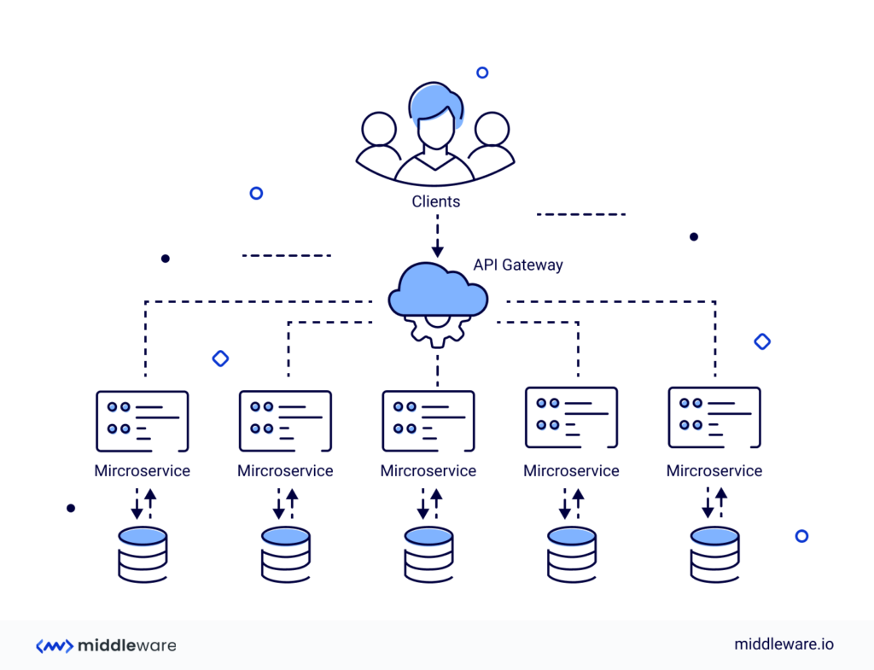

* 1. **Tools and Technologies**
     1. **Backend:** Node JS will be used for backend.
     2. **Frontend:** React JS will be used for frontend.
     3. **Database:** Mongo DB will be used for Database.

**UI design**

**Typography**

**Frames**

**Images**

**Trend Memes**

**User profile**

**Publish (mobile and website)**

**Logout**

**Mobile Dashboard**

**Mobile User Profile**

**Meme Sharing**

**API Integration**

* + 1. **Tools**

Following tools were used during development of the Project.

* VS Code
* POSTMAN
* UML and Draw.io

# DETAILED DESIGN AND ARCHITECTURE

This section provides a high-level overview of the system architecture. It defines how the functionality and responsibilities of the system ware partitioned and then assigned to subsystems.

# System Architecture

Basically the architecture of **MEMDY** which is been partitioned into three parts which are described below.

1. Centralized Database (**MONGODB**)
2. Website where memes will be created/edited and published to user profile.
3. Mobile Application both Android/IOS.

For the whole system centralized database has been designed for both Mobile app and Web Application. REST APIs are created which will be used for accessing the database and communication with server.

Web Application and Mobile Application is distributed into sub-modules which are described below.

**Web Application**

* Image Import and Export
* Editing Dashboard
* User Profile/Account
* Meme Publish mode

**Mobile Application**

* User Profile/Account
* Coin Generated Record
* Memes Gallery
* Likes
* Followers
* Memes dashboard

# Architecture Design Diagram

Following is the diagrammatic representation of the complete system architecture.

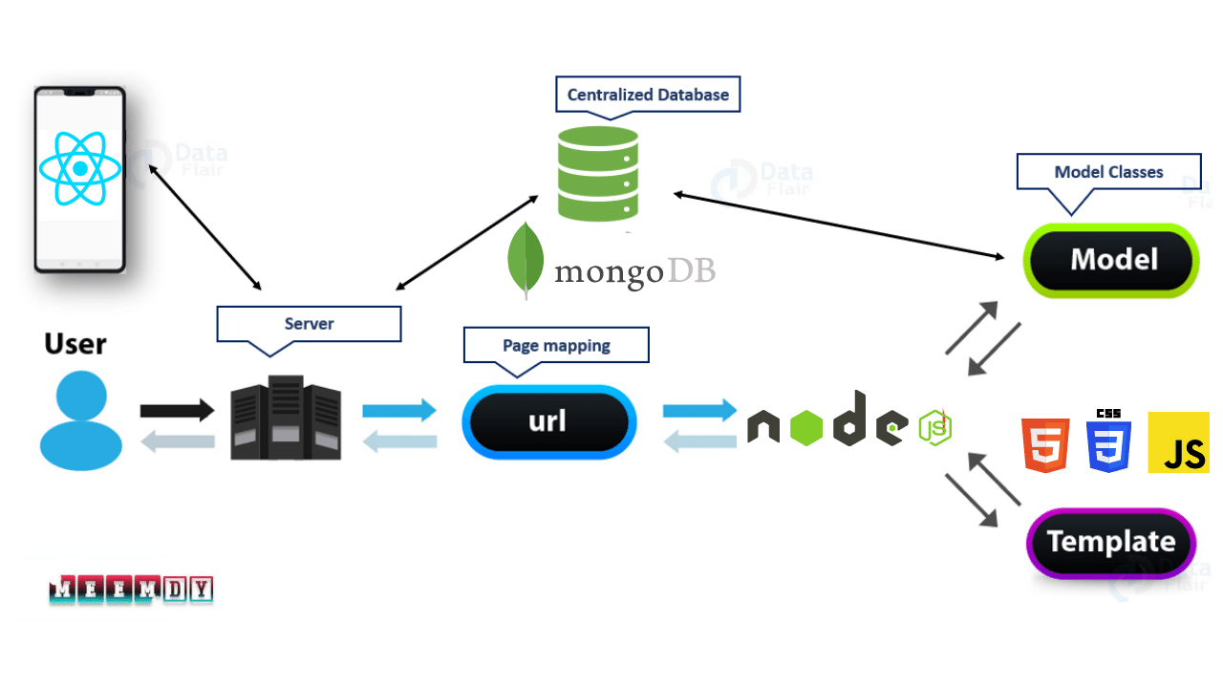

# Entity Relationship Diagram (ERD)

Entity Relation diagram defines the logical view of the system. It defines how the entities and their relations will translate into database schema and how the backend of our system will be implemented on the basis of that translated schema.

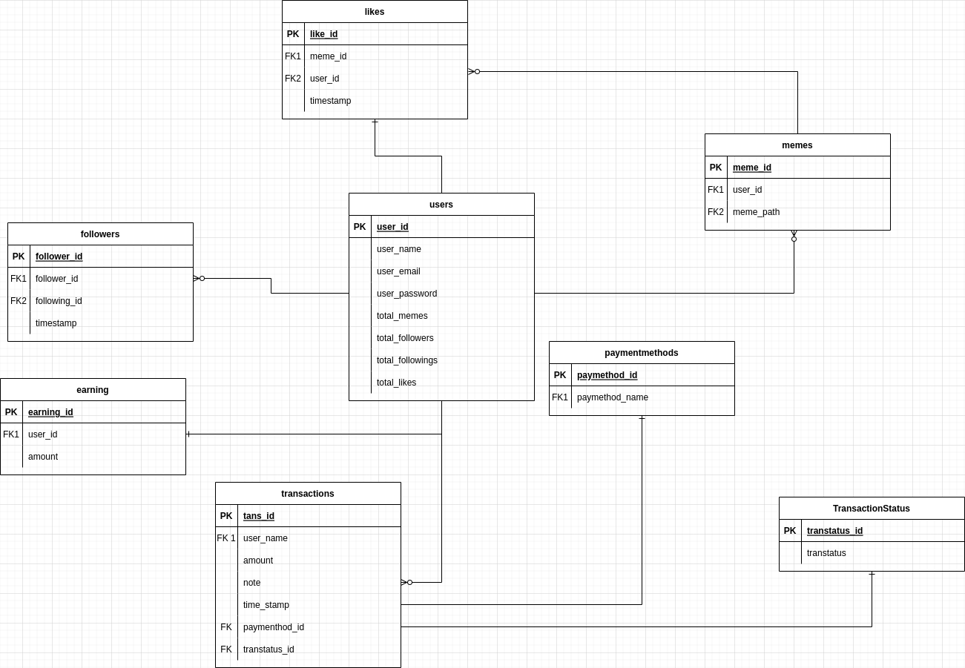

# Class Diagram

Class diagram defines the implementation perspective of system where these classes along with these relations will be coded in respective technology.

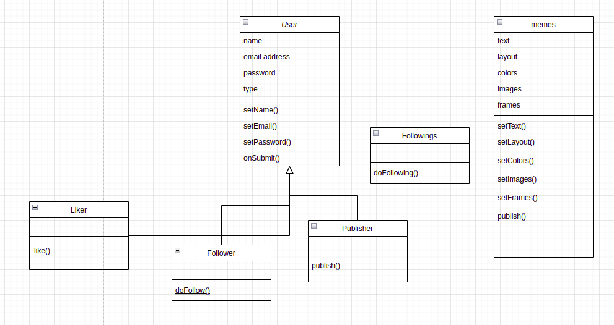

# Sequence Diagrams

This below sequence diagram describes the sequence of system.

**5.1 User Registration Sequence Diagram**

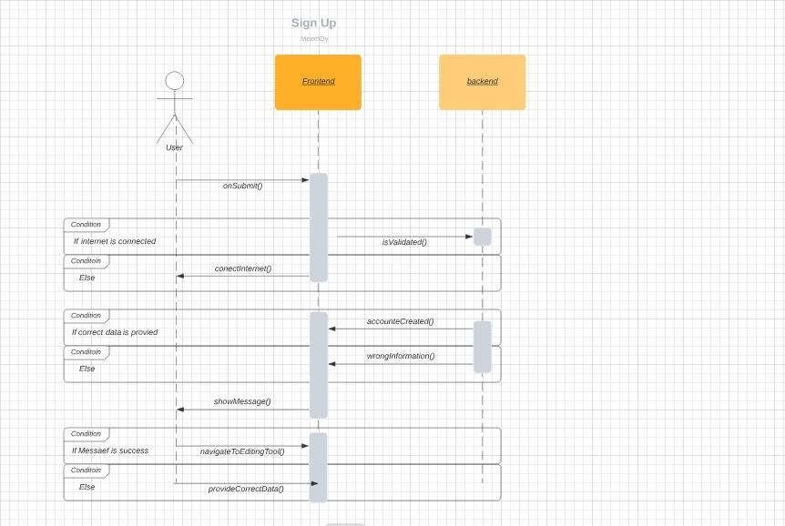

**5.2 User Login Sequence Diagram**

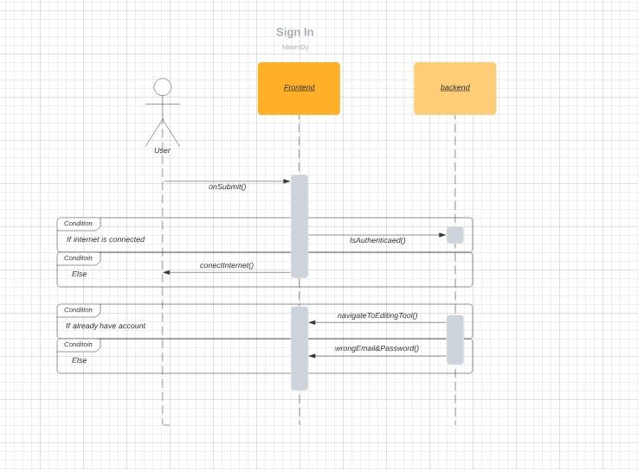

# Functional Requirements

This section specifies all the functional requirements which specify all basic functions of the system.

# Functional Hierarchy

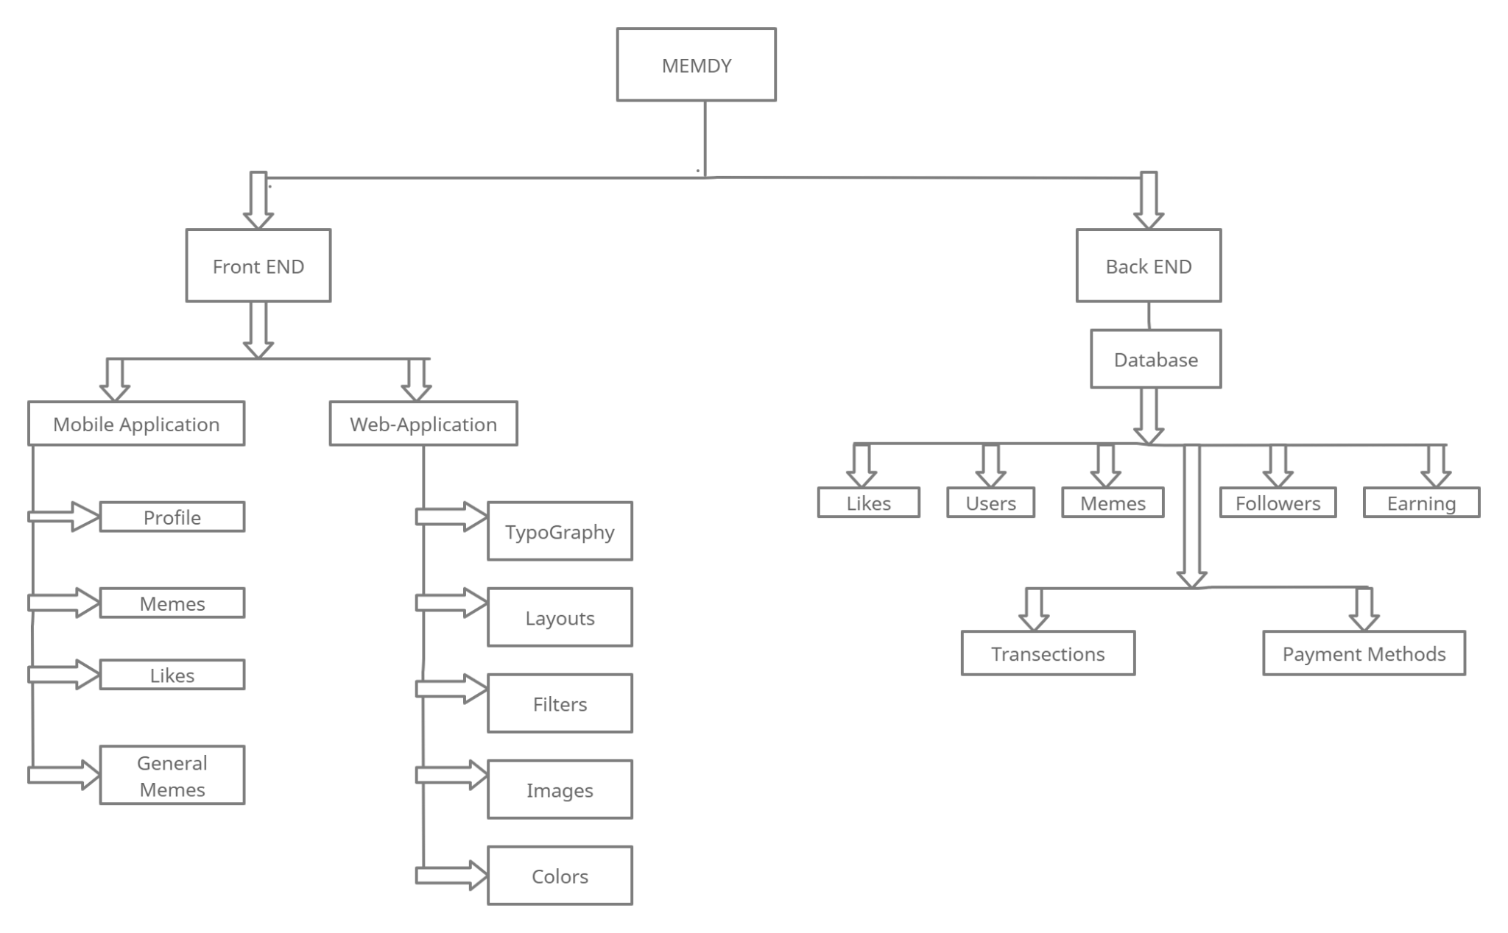

**6.2. Database Diagram**

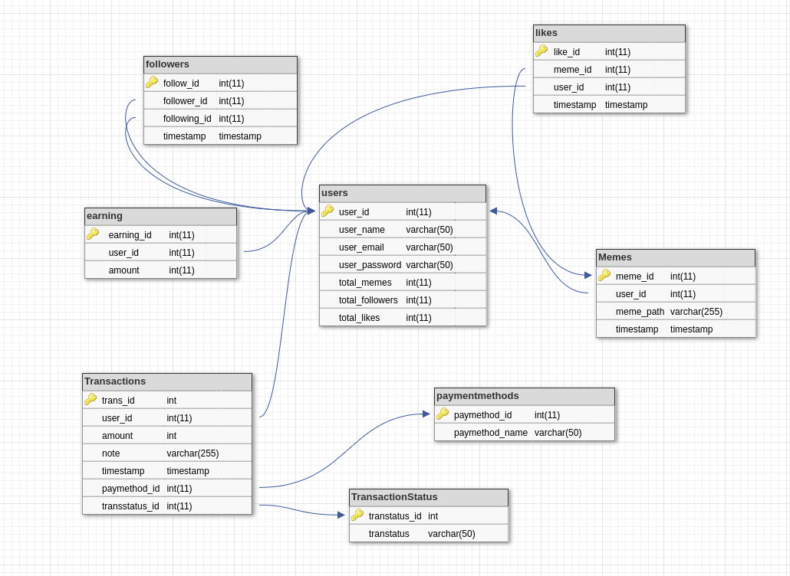

6.3 Use Case Diagram

There will be two primary actors of the system. Uses cases for each actor are as below.

|  |  |  |
| --- | --- | --- |
| **S No** | **Primary Actor** | **Use Cases** |
| 1 | Memer | Signup (web-browser and Mobile Application) |
| Login (web-browser and Mobile Application) |
| Create Memes |
| Publish memes which will be added to its profile |
| Add memes to its profile |
| Can earn coin through views, likes and share |
| Manage profile |
| Add and Delete memes from its profile |
|  |
| 2 | User | Signup |
| Login |
| View Memes |
| Visit profile of Memer |
| Like, share and dislike memes |

# Non-functional Requirements

This section outlines the fundamental non-functional requirements.

* 1. Performance Requirements

This section provides detailed specification of user interaction with the system along with performance of system.

**NFR-01:** Web-application will be loaded within 5 seconds.

**NFR-02:** Mobile Application will be opened on the spot depends on internet connection**.**

**NFR-03:** From web-application memes will be added to user profile and published within 5-7 seconds.

**NFR-04:** Web-application will be opened on any web browser.

**NFR-05:** Mobile application is compatible for android version greater than 4.2.

**NFR-06:** Mobile Application will provide same functionality to both android and IOS devices.

**NFR-07:** Both Mobile Application and web-application will perform its functions accurately.

* 1. Safety Requirements

NFR-08: Any exception which occur must be handled.

NFR-09: Both web-application and Mobile Application will not be crashed while in use.

NFR-10: In case of data lose Backup must be available.

* 1. Security Requirements

NFR-11: HTTP protocol will be used.

NFR-12: web-application will be hosted on secure server which will provide security.

NFR-13: Database will be stored on Mongo BD cloud.

# User Documentation

User manuals will be given when software will be delivered.

# IMPLEMENTATION AND TESTING

# System Implementation

The system has two parts, Web Application and Mobile Application. Details of each part has been giving below.

# Web Application

For Web Application development we use React library, and the web Application has the following modules shown in the figure.

# React-Native Framework

React Native is an open-source JavaScript framework, designed for building apps on multiple platforms like IOS, Android, and also web applications, utilizing the very same code base. It is based on React, and it brings all its glory to mobile app development.

**Advantages of React-Native Framework listed below:**

* Code Reusability. The biggest advantage of React Native is that developers don't need to create separate codes for different platforms (Android and IOS).
* Native Look and Feel.
* Live Reload.
* UI Focused.
* Cost-Efficiency.
* Third-Party Plugins.
* Large Community Support.

# Mobile App Development

For Mobile application development we used Flutter framework and the mobile app have the following modules.

# React-Native

React Native is an open-source JavaScript framework, designed for building apps on multiple platforms like IOS, Android, and also web applications, utilizing the very same code base. It is based on React, and it brings all its glory to mobile app development.

**Advantages of React-Native Framework listed below:**

* Code Reusability. The biggest advantage of React Native is that developers don't need to create separate codes for different platforms (Android and IOS).
* Native Look and Feel.
* Live Reload.
* UI Focused.
* Cost-Efficiency.
* Third-Party Plugins.
* Large Community Support.

# Database

We used MONGODB database for both Web Application development and Mobile application development.

# MongoBD

MongoDB is a non-relational document database that provides support for JSON-like storage. The MongoDB database has a flexible data model that enables you to store unstructured data, and it provides full indexing support, and replication with rich and intuitive APIs.

**Advantages of MongoDB are listed below:**

* Full cloud-based application data platform.
* Flexible document schemas.
* Widely supported and code-native data access.
* Change-friendly design.
* Powerful querying and analytics.
* Easy horizontal scale-out with sharding.
* Simple installation.
* Cost-effective.

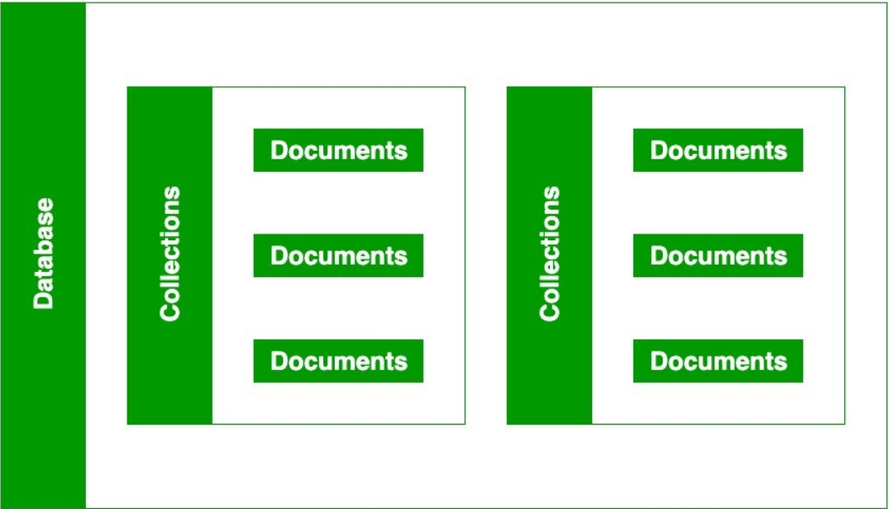

# Backend Implementation Details

This section provides implementation details of the backend services, APIs and overall structure.

# Working Endpoints for Front End Application

Endpoints have been created for the frontend application. Backend provides the following REST endpoints and methods.

* AUTHORIZATE: '/User/Memer/'
* LOGIN: '/user/sign in'
* SIGNUP: '/user/signup'
* GOOGLELOGIN: '/user/sign in/Google'
* GOOGLELOGINCALLBACK: '/user/sign in/Google/callback',
* Web Dashboard: ‘/Import Image/’
* Web Dashboard: ‘/Export Image/’
* Web Dashboard: ‘/Edit Meme/’
* Web Dashboard: ‘/Publish Meme/’
* Mobile Application: ‘/Gallery/’
* Mobile Application: ‘/Coins/’
* Mobile Application: ‘/Like/Followers/’

# Front End Design Implementation Details

This section provides implementation details of the frontend interfaces and screens.

# Web Application Login

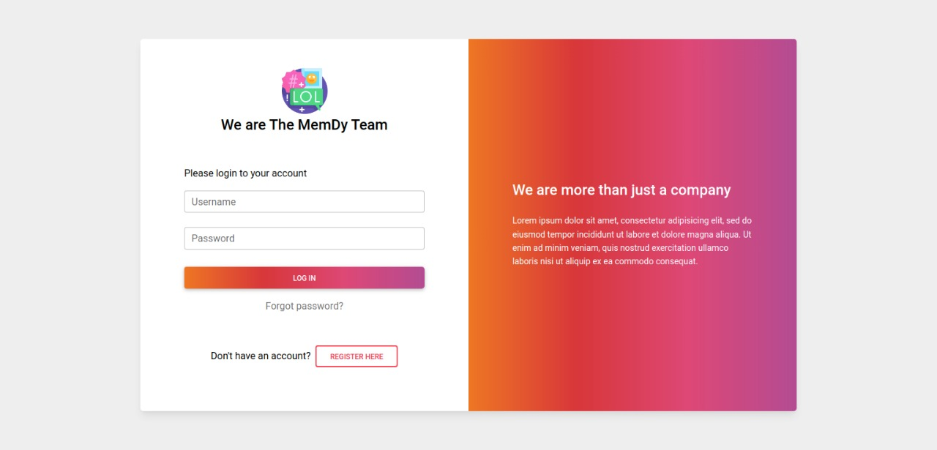

Figure 1

# Web Application Register

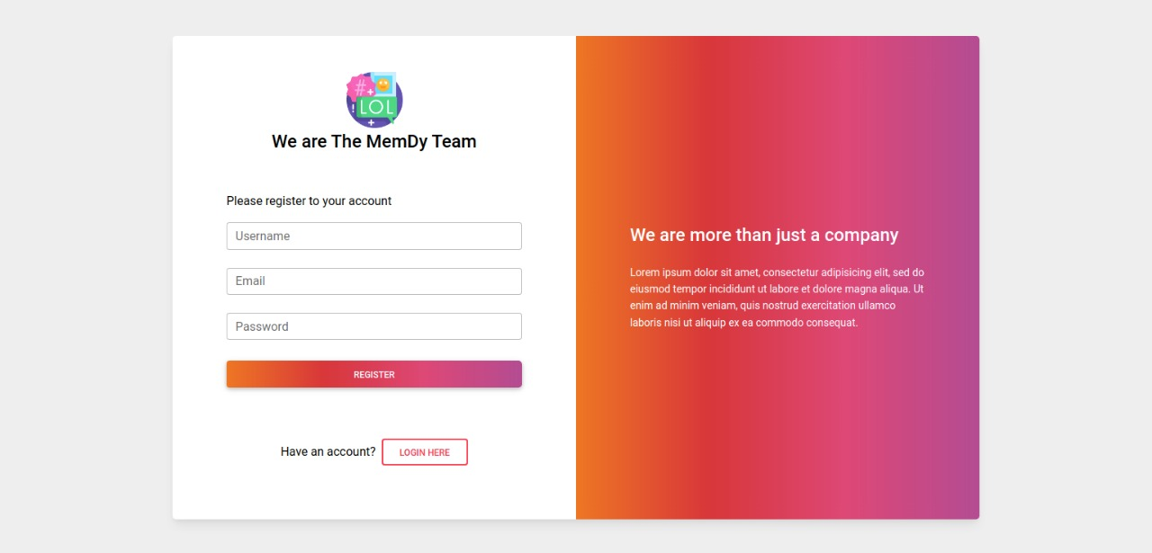

# Web Application Password Reset

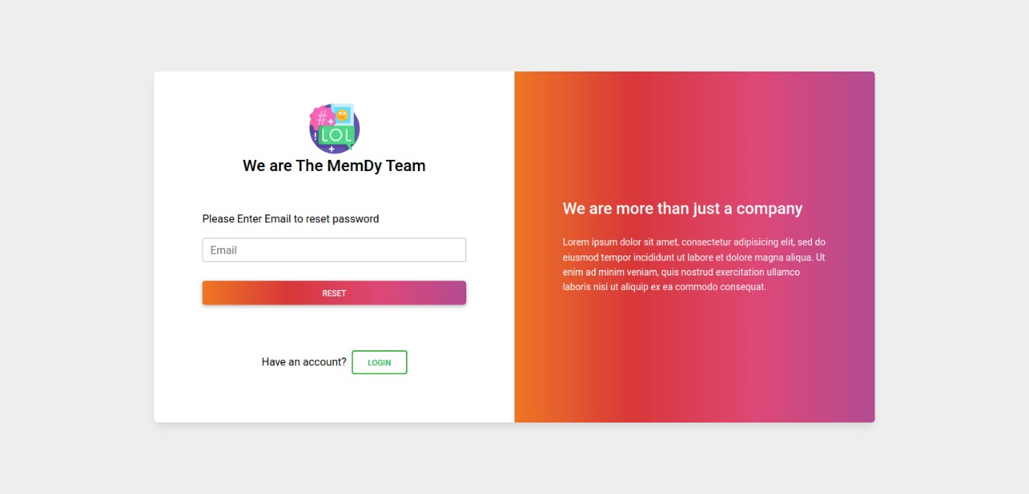

# Web Application Home Page

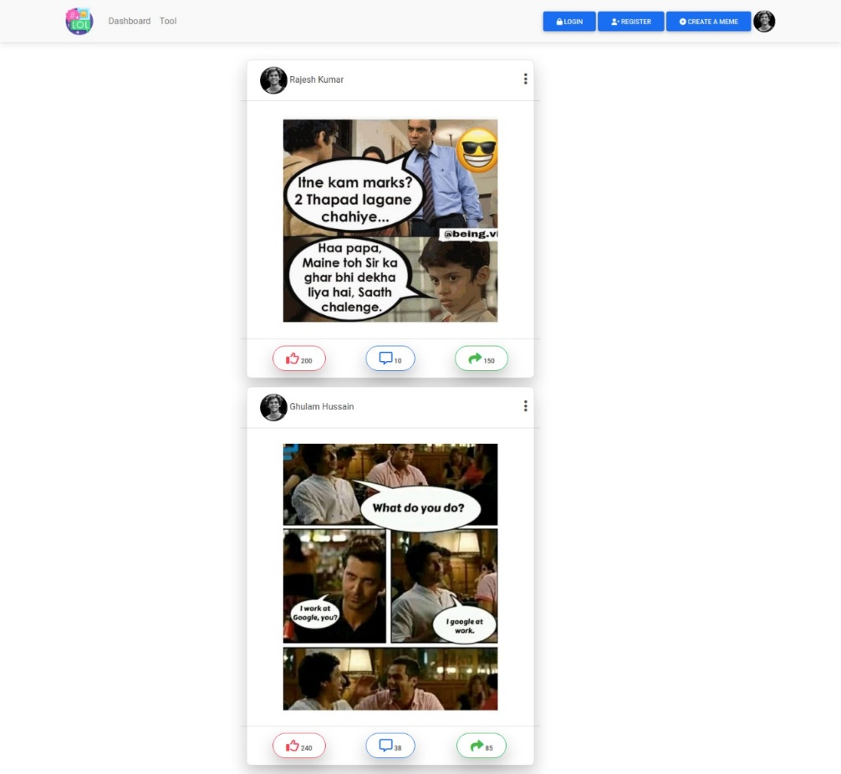

# Web Application Editing Dashboard

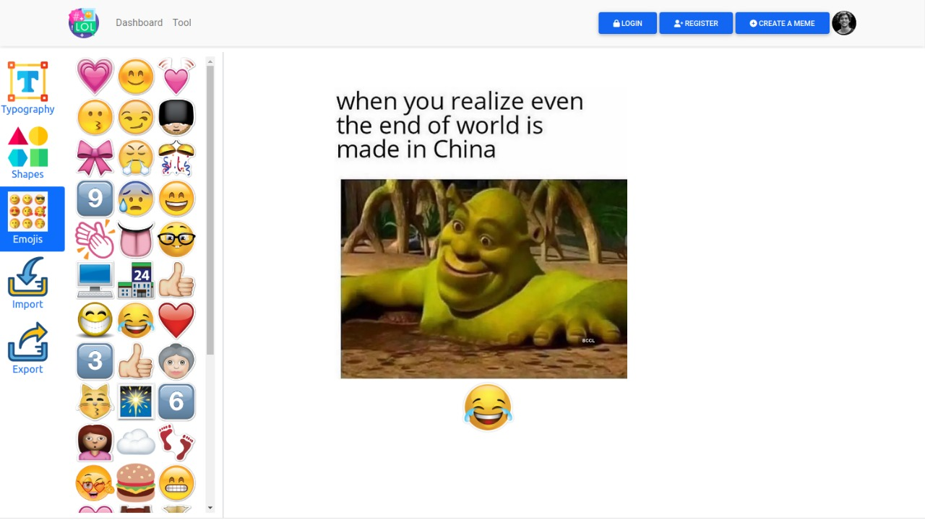

# Mobile Application

# Mobile App login & Sign Up

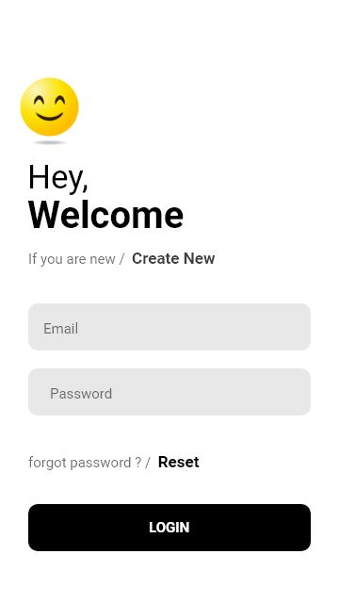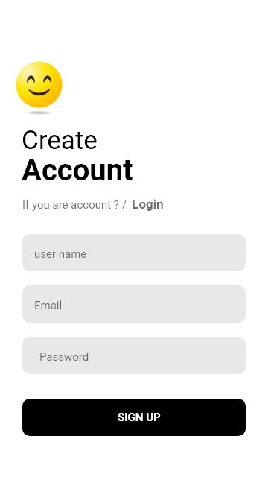

# Mobile Application Profile Screen

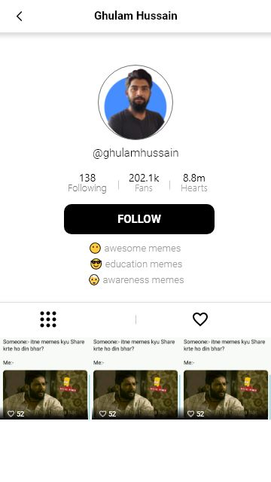

# Mobile Application Home Screen

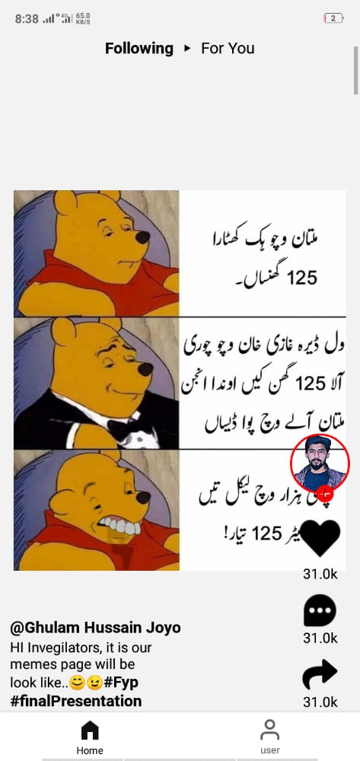

# CONCLUSION

MemDY is a complete solution provider tool for the memer’s which will provide them facilities to create memes and publish them on a single platform. It been observed that memer’s used to spend their time and energy to create and keep people mood fresh, for memer’s there’s no any specific platform for memer’s they used to share their created memes into different platforms like Facebook, Instagram and other social platforms where their identity is completely hidden and they don’t get any fame to overcome this problem MemDY is a perfect solution for memer’s community. MemDY provides memer’s a complete platform where they can earn money, get fame and build a career in memer’s community. MemDY is consist of both web Application and Mobile Application. On web Application memer’s can create memes and publish them to their profile, once they publish meme then that will be added to their profile which can be seen on mobile application on mobile application where memer’s created memes will be added to its profile from where users can follow that Memer like memes and they can do comments as well. As per the popularity (Followers), likes on memes coins will be generated and that will be redeemed and later will be converted into real money. Memer’s can be contacted by the brands/companies for promotion. In short it can be said that through this tool memer’s community can earn, fame and build a future and they don’t need to share their memes to other platforms.

# Limitations and Future Work

For this project design and implementation is time taking process and it require a good team to complete it on time, so due to this MemDY has few limitations which are mentioned below.

Since this is the first version of MemDY so it’s not fully functioned tool. It will take some more time to make it fully functioned tool.

Furthermore, our project has wide scope because it is targeting such a huge community so we cannot fulfill whole requirements, since its first version so we has included some functionalities for future work. Functionalities which will be implemented in future work are listed below:

* Coin Generation
* Improvement is interface
* Managing huge crowed
* Integration of other Languages.

# REFERENCES

1. [*Melanie Perkins*](https://www.google.com/search?q=Melanie+Perkins&stick=H4sIAAAAAAAAAOPgE-LWz9U3MDTKyDMqN1Pi1U_XNzTMMMnLyDU0N9NSz0620k8qLc7MSy0uhjPi8wtSixJLMvPzrNLyS_NSUosWsfL7puYk5mWmKgSkFmVn5hXvYGUEALGMNKVcAAAA&sa=X&sqi=2&ved=2ahUKEwjcte3roP30AhXQUWwGHRVdC74QmxMoAXoECC8QAw)*,*[*Cliff Obrecht*](https://www.google.com/search?q=Cliff+Obrecht&stick=H4sIAAAAAAAAAOPgE-LWz9U3MDTKyDMqN1Pi1U_XNzTMSMorKcswMdZSz0620k8qLc7MSy0uhjPi8wtSixJLMvPzrNLyS_NSUosWsfI652SmpSn4JxWlJmeU7GBlBAA4Ml1eWgAAAA&sa=X&sqi=2&ved=2ahUKEwjcte3roP30AhXQUWwGHRVdC74QmxMoAnoECC8QBA)*,*[*Cameron Adams*](https://www.google.com/search?q=Cameron+Adams&stick=H4sIAAAAAAAAAOPgE-LWz9U3MDTKyDMqN1Pi1U_XNzRMMy7LLik2qdRSz0620k8qLc7MSy0uhjPi8wtSixJLMvPzrNLyS_NSUosWsfI6J-amFuXnKTimJOYW72BlBABrZbo_WgAAAA&sa=X&sqi=2&ved=2ahUKEwjcte3roP30AhXQUWwGHRVdC74QmxMoA3oECC8QBQ)*. Perth, Australia, 2013.* [*www.canva.com*](http://www.canva.com)
2. [*www.memes.com*](http://www.memes.com)
3. *Xie, L., Natsev, A., Kender, J. R., Hill, M., & Smith, J. R. (2011, November). Visual memes in social media: tracking real-world news in youtube videos. In Proceedings of the 19th ACM international conference on Multimedia (pp. 53-62).*